ECE 4580 Final Project Proposal

Ethan Kim, Teng Li, <Sean your name here>

Vehicle License Number Recognition

Our project is about recognizing the license number of a vehicle. Todays, the number of vehicles on the roads are increasing to a extent where it is not feasible to manually watch over the people who do not follow the traffic laws. In order to automate the process of detecting those vehicles, our group will design a system where it identifies a vehicle that is captured from traffic cameras. Overall, this project will be a practical application of what we have learned throughout this semester.

The conditions we have to consider is the noise that are affected by weather condition or debris in the air and the blurs due to the relative motion between car and the camera.

We will plan to use adaptive median filtering for noise removal in this project because it uses spatial processing to preserve detail and smooth non-impulsive noise. After testing, we observed that the adaptive median filter performs better than median filter: it produces output image that has less noise and preserves edges and small structures.

(Sean Part)

After removing possible noise and deblurring an image, we will convert an image to grayscale and calculate histogram to contrast enhancement. Next, we have to detect the edge possibly with canny edge detector or sobel operator. Lastly, we will use optical character recognition to identify each characters.

Expected Result

1) expected deblur result

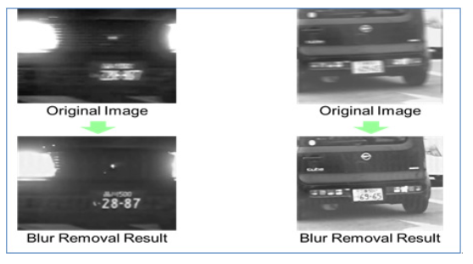

2) expected OCR result

